Meiosis notes
Gametes each contain only 23 chromosomes and are described as being haploid. When the gametes combine during fertilisation the resultant zygote has 23 pairs of chromosomes and is diploid. In this way the traits of both parents are inherited.
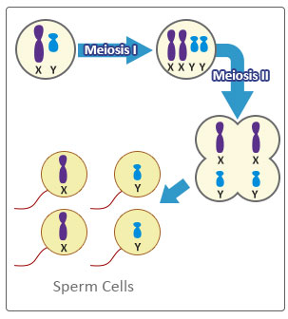
Meiosis only occurs in the gonads of organisms which reproduce sexually. Essentially after the initial replication of the DNA in the parent cell, it then undergoes two separate divisions producing four daughter cells, each with half the amount of DNA that was present in the parent cell.
In males spermatogenesis happens continuously in the testis for most of a man’s adult life and produces the male sex cell known as sperm. Millions of sperm are produced each day.
As you can see from the diagram, half the sperm produced will contain an X chromosome and half will contain a Y chromosome.
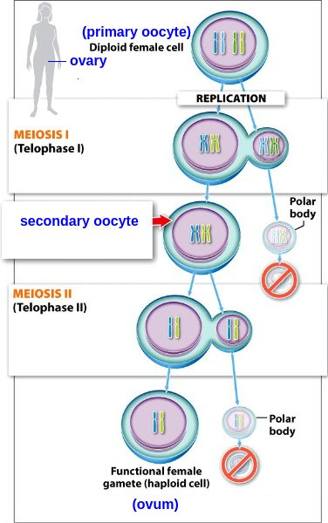
Oogenesis or the production of female sex cells known as eggs or ova, happens in the ovaries. Women are born with all the eggs that they will ever have already stored in their ovaries and each month one egg matures and is released so that it is available for fertilisation to take place.
Despite going through the same processes as sperm during meiosis each parent cell only produces one viable egg cell, the others become polar bodies and are absorbed by the body.
Unlike men who have XY sex chromosomes, the sex chromosomes in women are referred to as XX. Therefore every female gamete can only carry the X chromosome.

Questions
- How many chromosomes are there in:
- A haploid cell? ___________
- A diploid cell? ___________

- What are the names of the male and female gonads in animals?
__________________________________________________________________________________________________________________________________________________
- What do you think would happen if the gametes were produced by only one mitotic division?
___________________________________________________________________________________________________________________________________________________________________________________________________________________________

- Which gamete determines the sex of the zygote?
_________________________________________________________________________

- There are a number of examples of snakes and lizards that are able to reproduce by parthenogenesis. In this process the female can produce offspring without fertilisation taking place. Determine what proportion of the offspring would be female if parthenogenesis took place and explain your reasoning.
___________________________________________________________________________________________________________________________________________________________________________________________________________________________

- Flowering plants also reproduce sexually. Which structures produce the sperm and the eggs in a flowering plant?
___________________________________________________________________________________________________________________________________________________________________________________________________________________________

- Propose a reason why some genetic disorders only affect the males in a family.
_____________________________________________________________________________________________________________________________________________________________________________________________________________________________________________________________________________________________________________________________________________________________________________

